Project Development –Delivery plan sprint-3

IoT Based Safety Gadget for Child Safety Monitoring & Notification

**TEAM ID:**PNT2022TMID07784

**Creating Cloudant DB and integrating Node-Red with the Web UI**

**Create Cloudant DB:**

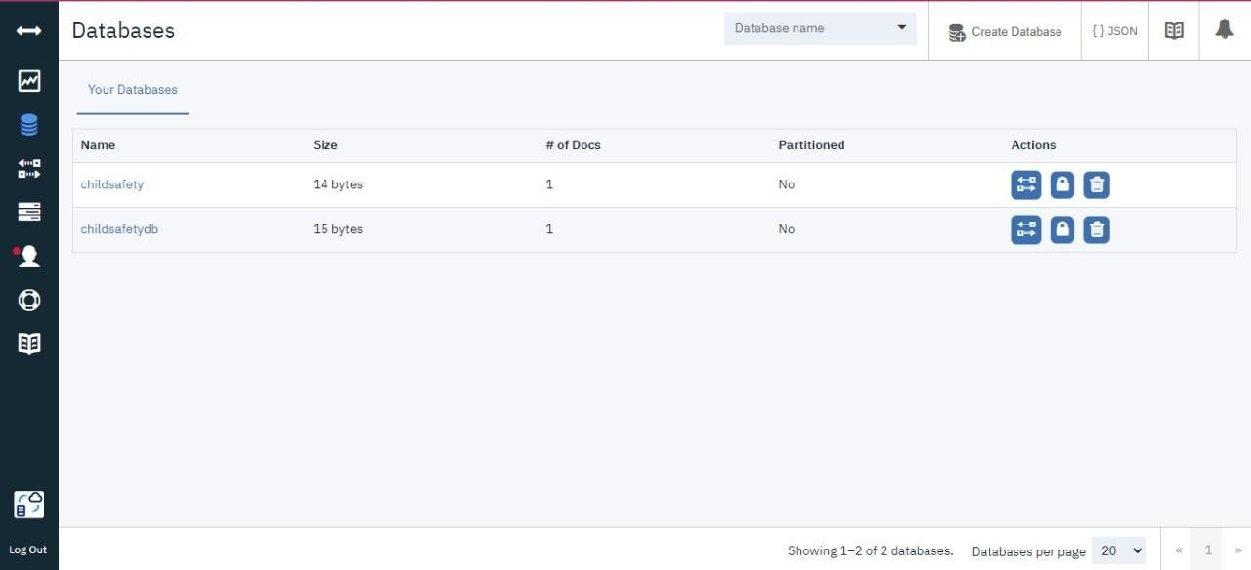

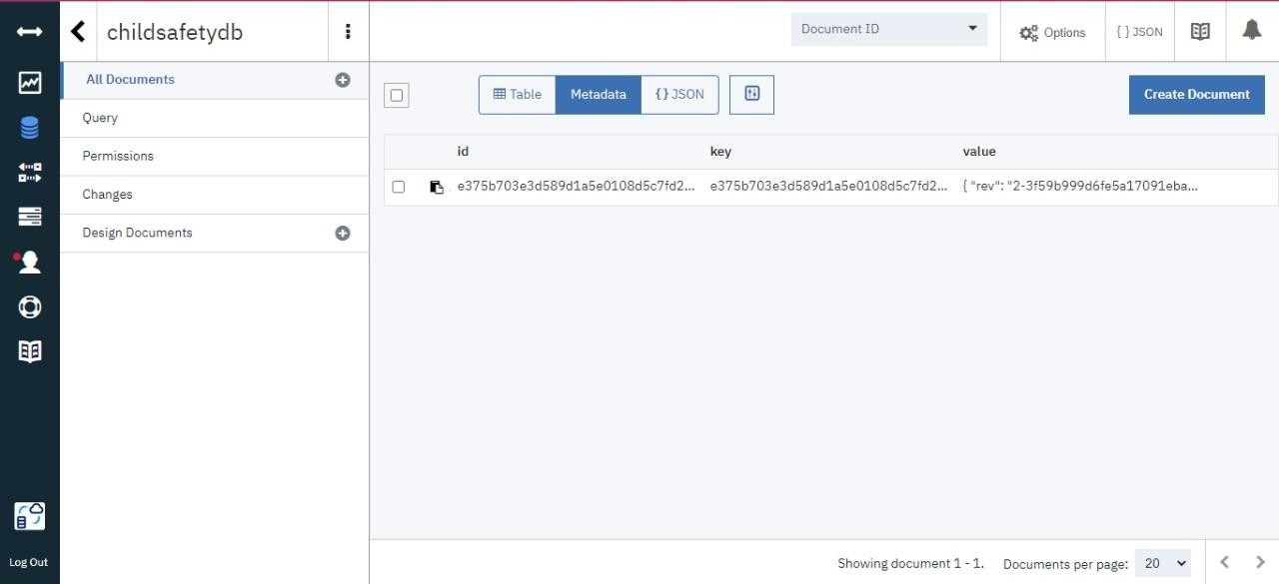

**Node-Red Service with Cloudant Database:**

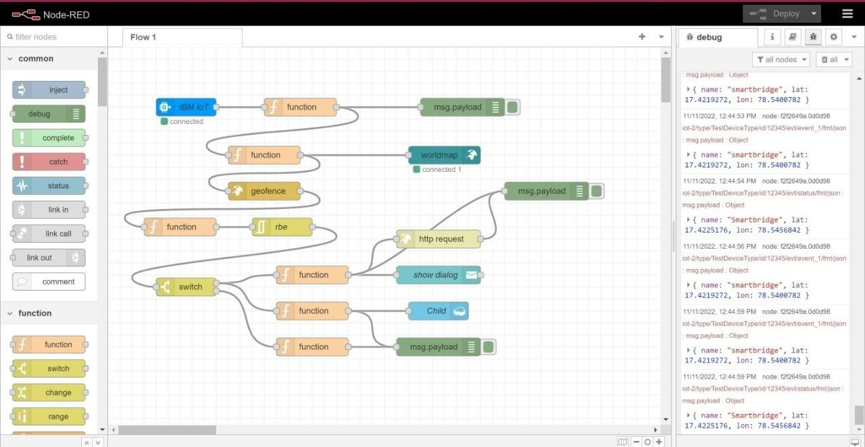

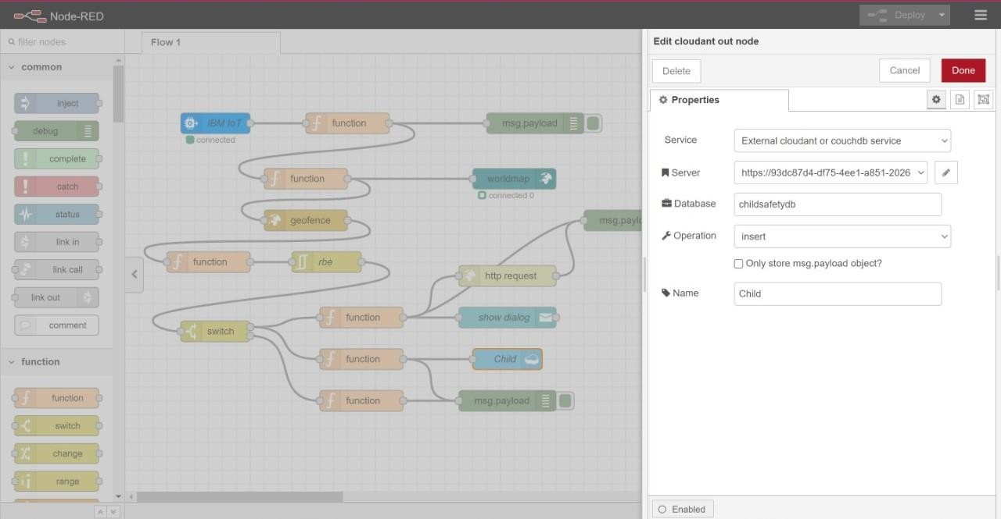

**Node-Red Dashboard(Web ui):**

